*[Decision Making and Analysis](https://ojs.luminescience.cn/DMA).* 2023; 1(1): 1-9. doi:https://doi.org/10.55976/dma.1202311371-9

**Original Research**

**The role of intelligent transportation systems in solving traffic problems and reducing environmental negative impact of urban transport**

**Ibrahim Badi*1, Mouhamed Bayane Bouraima2, L. J. Muhammad3**

1 Libyan Academy, Department of Mechanical Engineering, Misurata, Libya

2 School of Civil Engineering, Southwest Jiaotong University, Chengdu, Sichuan Province, China

3 Mathematics and Computer Science Department, Federal University of Kashere, Gombe, Nigeria

## **\***Correspondence to: [i.badi@lam.edu.ly](mailto:i.badi@lam.edu.ly)

## Abstract: Information technology has produced many modern systems in the field of intelligent transportation that aim to integrate existing and new systems for the management of transportation and traffic networks to respond to changing (dynamic) traffic conditions. These systems have been applied in many Western countries for several purposes, the most important of which are traffic safety and the reduction of losses resulting from poor planning of these networks. Many transport systems in developing countries continue to suffer from many problems, such as high accident rates, traffic congestion, and pollution from car exhaust. This paper aims to use multi-criteria decision-making methods to help select the best technology to overcome the traffic problems in Libya. A hybrid model of Analytic Hierarchical Process (AHP) and the Measurement Alternatives and Ranking according to Compromise Solution (MARCOS) method was used. The AHP method was used to determine the weights of six technologies for intelligent systems, with the results showing that the most appropriate technology was surveillance cameras, with a weight of 28%. The resulting weights were used to rank the impact of these technologies on safety, environment and efficiency. This study can help decision makers on selection of the best systems that can be used to overcome the current problems faced by the transportation system.

**Keywords**: MCDM, MARCOS, Intelligent transportation, AHP

## Introduction

Transportation is the main pillar of the economy because of its effective role in meeting the needs of different sectors, activating government commerce, and satisfying the needs of members of society [1]. However, the increase in population and its dependence on transportation modes has led to the emergence of a series of traffic problems such as traffic congestion and accidents, high levels of pollution, increased travel time, and energy consumption [2]. These problems can be partially solved with the traditional methods by building new roads or expanding existing ones, which has only provided a short-term solution, but represents an increasing financial, operational and environmental burden in the long run. However, the technical development observed in the 21th century, with the great expansion of information technologies and their application, provides modern and radical solutions to these problems through intelligent transport systems that allow the maximum use of unused latent capacity for the road, relying on modern technologies to achieve a more efficient traffic management.

Intelligent transportation systems have several objectives, including increasing the operational efficiency of the transportation system and expanding its capacity by taking a series of measures such as increasing speeds and reducing stops, reducing delays at intersection points between transportation modes, and improving the management of the road network by adopting the activation of the transportation capacity of the road network [3]. They also aim to improve commuter travel and comfort levels by reducing flight time, increasing its reliability, reducing its cost, increasing the level of personal safety and security, and so forth. In addition, these systems also aim to improve the level of road safety by reducing the number, severity and cost of accidents, resulting in fewer fatalities and increased personal safety. On the energy side, the goal is to reduce energy consumption and limit adverse environmental impacts by reducing exhaust emissions and fuel consumption due to congestion, reducing noise pollution, and reducing traffic inconvenience in residential areas [4].

Many previous research studies have analyzed the impact of these systems on road safety, the environment, and efficiency improvements. For example, Balasubramaniam et al. performed analysis of the recent sustainable transportation methods in the Internet of Vehicles [5]. Zhao et al. conducted a survey on the contribution of intelligent transportation systems to environmental sustainability in smart cities [6]. Ersoy and Boruhan studied the importance and usage of the intelligent transportation systems with its applications in Turkey [7]. Yuko et al. used data envelopment analysis to measure performance of the intelligent transportation systems of public sector investments [8]. Zhicai et al. measured the socio-economic impact of intelligent transportation systems [9]. Zhang and Lu built a vehicle movement model using OPNET modeler software [10]. Kaffash et al. reviewed comprehensively the application of intelligent transportation systems and the most recognized models with Big Data used in this context [11].

This paper aims to investigate the impact of intelligent transportation systems in solving traffic problems and reducing pollution by using multi-criteria decision-making methods. Six intelligent transportation systems are suggested in this research. The assessment system's model is created, and the importance of the evaluation indicators is established. This approach enables the measurement of the impact of these systems on three different indicators. The paper is structured as follows. In section 2, we discussed the approach of intelligent transportation systems. After that, we discussed the methods used to rank the alternatives. In section 4, we present the findings of the model. The final section is devoted to the study's conclusion.

**1. Intelligent transportation systems**

Intelligent transportation systems are primarily composed of several subsystems [12], each of which performs many functions that help solve traffic problems and high pollution rates, summarized below:

**1.1 Advanced traffic management systems:**

They include various subsystems that provide the real-time control center with various data on the real-time traffic situation and forecast its conditions, allowing for more efficient planning of operations. These systems can contribute to traffic control by evaluating the performance of freeways and streets with traffic signals and coordinating between them and between public transportation operations to balance demand and capacity within the transportation system. They also endeavor to improve incident response time by using advanced technologies that quickly detect and verify the presence of emergency incidents. This reduces the time it takes to dispatch crews and equipment to deal with these incidents. These systems also help manage congestion and the negative impacts that caused by it, by decreasing travel time, cost, and the risk of accidents, as well as decreasing pollution from fuel burned during congestion. These systems can also manage the demand for transportation by applying the system of using traffic lanes for vehicles with a high number of passengers, as well as controlling the parking lots, their cost, the pricing of entry to the roads and using methods to give preference to the traffic [13].

**1.2 Advanced traveller information systems:**

These systems collect, analyze, communicate and display information from the relevant authorities in order to help users travel from their place of departure to their destination, providing them with information that allows them to choose the appropriate modes of transportation, travel times, route selection decisions before departure, and also helps them during the trip to reach their destination in the shortest time and using the shortest routes, in addition to providing them with the information about road emergencies, traffic jams and available alternatives.

**1.3 Advanced vehicle monitoring systems:**

Advanced vehicle monitoring systems offer state-of-the-art technologies by combining sensors, computers and vehicle control systems, and help vehicles identify and avoid obstacles they encounter. These systems can help avoid a forward accident by pre-detecting potential collisions and fixed obstacles in front of and behind the vehicle, improving driver performance to avoid them, as well as temporary vehicle control in the case of advanced systems, which helps reduce vulnerability to injury and damage. It can also contribute to side-impact collision avoidance by providing collision warning when moving from street to street and off the side of the road, helping to reduce side-impact collisions and their damage.

**1.4 Commercial vehicle operations systems:**

These include a set of satellite-linked navigation systems, a microprocessor and a digital radio. They can be used in commercial vehicles, allowing for continuous monitoring of truck traffic. These systems allow an electronic prepayment service for commercial vehicles equipped with the necessary automatic communication devices to pass through checkpoints such as: gas stations and international borders without the need to stop if their documents and loads are regular. It also automates roadside security checks of documents, vehicles and drivers to quickly detect any malfunctions in necessary vehicle systems, verify that drivers are ready to drive and ensure the validity of their documents. It also assists in the rapid response to and handling of accidents involving hazardous materials by providing information on hazardous material leaks and reporting them to emergency vehicles such as civil protection vehicles for action.

**2. Methodology**

Operations research methods and quantitative techniques have generally been widely used in managerial, productive, economic and even political decision making. This is the result of its holistic vision and its consideration of all criteria that may be contradictory, from the point of view of decision makers at the level of institutions, organizations and even states [14]. The use of multi-criteria decision-making methods has increased in recent years. Many methods have developed and been used in many applications [15-17]. In this research, a hybrid model that including the hierarchical analysis theory and the MARCOS method was used. The AHP method is one of the most often used methods in many decision-making problems. It is particularly effective in addressing the problem of criteria weighting. MARCOS method was developed recently to address the drawbacks of earlier methods. In comparison to approaches based on related concepts, i.e. defining the distance of alternative from the reference points, MARCOS method shows more stability. AHP method was used to determine the weights of the different criteria, and then the MARCOS method was used to rank the different alternatives.

The methodology used in this study is shown in Figure 1, where the AHP method was used to calculate the weights of the criteria. Following that, the MARCOS method was used to rank alternatives. The three approaches ARAS, SAW, and WASPAS were used to compare the alternatives. Finally, sensitivity analysis was performed.

Identifying the need for research

Defining the research's objectives

Formatting criteria and alternatives

Conducting the assessment

Determining the criteria weights using AHP method

Ranking the alternatives using MARCOS method

Sensitivity analysis, and comparison with ARAS, SAW, and WASPAS methods

**Figure 1** Methodology of the research

AHP method is one of the methods adopted in multi-criteria decision making that adopts the use of quantitative methods in the decision-making process of selecting the optimal alternative from a range of alternatives based on multiple criteria, where the theory has proven successful and very effective in solving complex problems and multi-criteria decision making, and many studies have been conducted worldwide to address the issue of trade-offs and the choice between a range of alternatives [18]. The hierarchical analysis process starts with the hierarchical placement of the problem criteria to be addressed, then we performed a pairwise comparison between the problem elements at one level, based on the selection criteria, and from these comparisons we obtained priorities, and finally we reached the overall priorities, and thus calculated the stability and extent of overlap between the elements. The method is based on the concept of pairwise comparison of different criteria. The steps of the method can be summarized as follows [19]:

Step 1: Hierarchical construction by defining the problem, the criteria that affect it, and the proposed alternatives for the solution.

Step 2: Pairwise comparison of the sub-criteria among themselves, of the main criteria among themselves, and then calculation of their weight in relation to the objective.

Table 1 Shows the relative importance according to a Saaty classification.

**Table 1**  Relative importance according to Saaty classification

|  |  |
| --- | --- |
| Interpretation | Weight |
| Equally important | 1 |
| One of the two criteria is moderately more important than the other | 3 |
| The importance of one criterion is strongly higher than the other | 5 |
| One of the two criteria is highly important than the other | 7 |
| The importance of one of the two criteria is superior to the other | 9 |
| Average values between previous weights | 2,4,6,8 |

Step 3: Check the percentage of consistency required for a successful pairwise comparison to ensure that opinions do not contradict each other. This value should not exceed 10%.

Step 4: Use the criteria weights to establish priorities.

The MARCOS method is based on defining the relationship between alternatives and reference values (ideal and anti-ideal alternatives). Decision-making preferences are defined based on utility functions. A utility function is the position of an alternative in relation to the ideal and anti-ideal solutions. The best alternative is that closest to the ideal point and farthest from the anti-ideal point. It was developed by Stevic et al. in 2020 [20]. The steps of the method can be summarized as follows [21]:

Step 1. The formation of the initial decision matrix.

Step 2. The formation of an extended initial matrix. This step defines the ideal and anti-ideal solutions. The ideal solution is an alternative with the best alternative for certain criteria, whereas the anti-ideal solution is the worst alternative for certain criteria. This is based on the following equations:

$AAI=\min_{j}{x_{ij}} if j∈B and AAI=\max_{j}{x_{ij}} if j∈C$ (1)

$AI=\max_{j}{x_{ij}} if j∈B and AAI=\min_{j}{x_{ij}} if j∈C$ (2)

where B stands for the criteria to be maximized, and C stands for the criteria to be minimized.

Step 3. The normalization of the extended initial matrix. Normalization is performed by using the following equations:

$n_{ij}=\frac{x_{ai}}{x_{ij}} if j∈C$ (3)

$n_{ij}=\frac{x_{ij}}{x_{ai}} if j∈B$ (4)

where the elements and represent the elements from the initial decision matrix. ij x ai x

Step 4. The determination of a weighted matrix. Aggravation is performed by multiplying normalized matrix values by corresponding weights.

Step 5. The calculation of the utility degree of the alternatives Ki. The utility degree is determined by applying the following equations:

|  |  |  |
| --- | --- | --- |
|  | $$K_{i}^{−}=\frac{S_{i}}{S_{aai}}$$ | (5) |

|  |  |  |
| --- | --- | --- |
|  |  | (6) |

where (i=1,2,..,m) represents the sum of the elements of a difficult matrix: i S

|  |  |  |
| --- | --- | --- |
|  | $$S_{i}=\sum_{i=1}^{n}{v_{ij}}$$ | (7) |

Step 6. The formation of the utility function of the alternatives f(Ki). The utility function is calculated by using the following equation:

|  |  |  |
| --- | --- | --- |
|  | $$f\left(K_{i}\right)=\frac{K_{i}^{+}+K_{i}^{−}}{1+\frac{1−f\left(K_{i}^{+}\right)}{f\left(K_{i}^{+}\right)}+\frac{1−f\left(K_{i}^{−}\right)}{f\left(K_{i}^{−}\right)}}$$ | (8) |

where f($K_{i}^{−}$) is the utility function versus the anti-ideal solution, while f($K_{i}^{+}$) is the utility function versus the ideal solution. The utility functions are calculated by using the following equations:

|  |  |  |
| --- | --- | --- |
|  | $$f\left(K_{i}^{−}\right)=\frac{K_{i}^{+}}{K_{i}^{+}+K_{i}^{−}}$$ | (9) |

|  |  |  |
| --- | --- | --- |
|  |  | (10) |

Step 7. Ranking the alternatives. A rank is formed based on the final value of the utility function. It is desirable that the alternative should have the greatest value of the utility function.

Libya was chosen as a case study. Libya suffers from poor infrastructure, poor condition of roads due to their age, a lack of traffic lights, high rates of traffic accidents, and a lack of public transportation.

## **3. Case study**

The Libyan transport system relies on a modest range of methods such as air planes, cars, and trucks, with almost total reliance on land transport for domestic transport. The reliance on trucks and private cars for road transport of people and goods has secondary effects, both environmentally (air pollution and noise) and in terms of high accident incidence and high land use. As dependence on these systems increases, these negative effects worsen. For example, the accident fatality rate is 26.1 persons per 100,000 population, which is one of the highest in the world. This may be due to the road network, which has become dilapidated and needs to be further developed, along with the high number of cars in the country. In 2013, the total number of registered vehicles reached 3,553,497 vehicles. Figure 2 shows the number of deaths caused by road accidents from 1995 to 2018. It is clear that these numbers are high and increasing at a terrifyingly high rate compared to other countries in the world. When it comes to intelligent transportation systems, needless to say, there are none currently in the country. It is safe to say that most intersections lack normal traffic signals, and even if they do exist, they are more likely to be out of order. The road signs are very sparse and may not be respected.

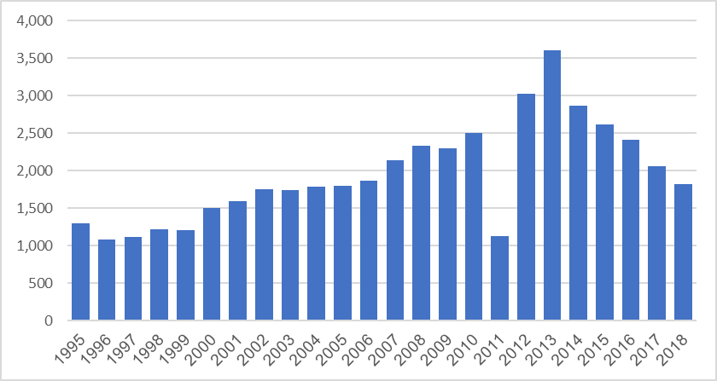

**Figure 2** Number of deaths caused by traffic accidents in Libya during 1995-2018

Updating this weak system with an intelligent one could be helpful in reducing accidents in this country whose streets are bleeding due to traffic accidents. From this, six intelligent systems were proposed: surveillance cameras (S1), intelligent automatic control systems (S2), intelligent traffic signals (S3), variable message signs (S4), intelligent intersection management (S5), and intelligent media systems (S6). Four experts in the field of transportation were invited to participate in the evaluation of these systems and the result of the pairwise comparison is presented in Table 2.

**Table 2** Pairwise comparison of intelligent transportation systems

|  |  |  |  |  |  |  |
| --- | --- | --- | --- | --- | --- | --- |
|  | **S1** | **S2** | **S3** | **S4** | **S5** | **S6** |
| **S1** | 1 | 3 | 2 | 6 | 4 | 8 |
| **S2** | 1/3 | 1 | 3 | 5 | 3 | 6 |
| **S3** | 1/2 | 1/3 | 1 | 4 | 3 | 5 |
| **S4** | 1/6 | 1/5 | 1/4 | 1 | 1 | 3 |
| **S5** | 1/4 | 1/3 | 1/3 | 1 | 1 | 5 |
| **S6** | 1/8 | 1/6 | 1/5 | 1/3 | 1/5 | 1 |

Table 3 shows that surveillance camera systems lead with a weight of 38%, followed by intelligent automatic control systems with a weight of 26%.

**Table 3** Priority ranking of the potential intelligent transportation systems

|  |  |  |
| --- | --- | --- |
| **No.** | **System** | **Priority** |
| S1 | surveillance cameras | 38.8% |
| S2 | intelligent automatic control systems | 26.0% |
| S3 | intelligent traffic signals | 17.4% |
| S4 | variable message signs | 6.30% |
| S5 | intelligent intersection management | 8.50% |
| S6 | intelligent media systems | 3.10% |

After the suggested systems' weights were calculated, their impact on Safety (A1), Performance, and Environment (A3) is ranked using MARCOS method. Based on the experts' opinions, an initial decision matrix was prepared (Table 4).

**Table 4** The initial decision matrix

|  |  |  |  |  |  |  |
| --- | --- | --- | --- | --- | --- | --- |
| **Weights** | **0.388** | **0.260** | **0.174** | **0.063** | **0.085** | **0.031** |
| Impact | S1 | S2 | S3S3 | S4 | S5 | S6 |
| A1 | 90 | 70 | 70 | 80 | 50 | 40 |
| A2 | 60 | 80 | 100 | 60 | 90 | 50 |
| A3 | 40 | 20 | 15 | 10 | 10 | 30 |
| **MAX** | **90** | **80** | **100** | **80** | **90** | **50** |

After that, the data is normalized. The normalization is conducted using a simple linear normalization. Since all criteria are of benefit type, the maximum value of the criteria is calculated. The normalization of the initial decision matrix is step 3 of the MARCOS method (Table 5).

**Table 5** The normalized decision matrix

|  |  |  |  |  |  |  |
| --- | --- | --- | --- | --- | --- | --- |
| **Strategies** | **S1** | **S2** | **S3S3** | **S4** | **S5** | **S6** |
| A1 | 1.000 | 0.875 | 0.700 | 1.000 | 0.556 | 0.800 |
| A2 | 0.667 | 1.000 | 1.000 | 0.750 | 1.000 | 1.000 |
| A3 | 0.444 | 0.250 | 0.150 | 0.125 | 0.111 | 0.600 |

Subsequently, the aggregated values were calculated by use of the weighting coefficients. Next step is the calculation of the utility degree. In order to perform this step, it was first necessary to determine the ideal and anti-ideal solutions. The ideal solution represents the maximum value of a certain criterion, whereas anti-ideal values represent the minimum value of a specific criterion. Then, the values for the individual alternatives and for the ideal and anti-ideal solutions were summed up and the utility degrees were calculated (Table 6).

. **Table 6** The weighted normalized decision matrix and the negative-ideal solution

|  |  |  |  |  |  |  |
| --- | --- | --- | --- | --- | --- | --- |
| **Strategies** | **S1** | **S2** | **S3S3** | **S4** | **S5** | **S6** |
| A1 | 0.388 | 0.228 | 0.122 | 0.063 | 0.047 | 0.025 |
| A2 | 0.259 | 0.260 | 0.174 | 0.047 | 0.085 | 0.031 |
| A3 | 0.172 | 0.065 | 0.026 | 0.008 | 0.009 | 0.019 |
| **Ideal** | 0.388 | 0.260 | 0.174 | 0.063 | 0.085 | 0.031 |
| **Anti Ideal** | 0.172 | 0.065 | 0.026 | 0.008 | 0.009 | 0.019 |

The sixth step of the MARCOS method was to form the utility function of the alternatives. The utility function was calculated. In order to calculate the utility function of the alternatives, it was necessary to calculate the utility function in relation to the ideal and anti-ideal solutions. The inclusion of these values generated the final value for the alternatives (Table 7) and determined the ranking of the suppliers.

**Table 7** The relative assessment matrix and the assessment scores of alternatives

|  |  |  |  |  |
| --- | --- | --- | --- | --- |
| **Measure** | $$K_{i}^{−}$$ | $$K_{i}^{+}$$ | **F(ki)** | **Rank** |
| A1 | 2.913 | 0.871 | 0.815 | **1** |
| A2 | 2.858 | 0.855 | 0.800 | **2** |
| A3 | 1.000 | 0.299 | 0.280 | **3** |

The result shows that the use of intelligent systems will have an impact on safety in the country. The fight against road accidents is an obsession for the authorities concerned as well as for the citizens. The use of these systems will minimize this problem. In second place comes the performance of the transport system. The country suffers from severe traffic congestion due to the almost total dependence of citizens on their private cars. As the number of cars increases, intelligent road management will help alleviate the congestion problem.

In addition, a comparison analysis has been conducted to demonstrate the validity and stability of the MRCOS method. Three different multi criteria methods were used, ARAS model, SAW method, and WASPAS method. Figure 3 shows the results obtained by these methods.

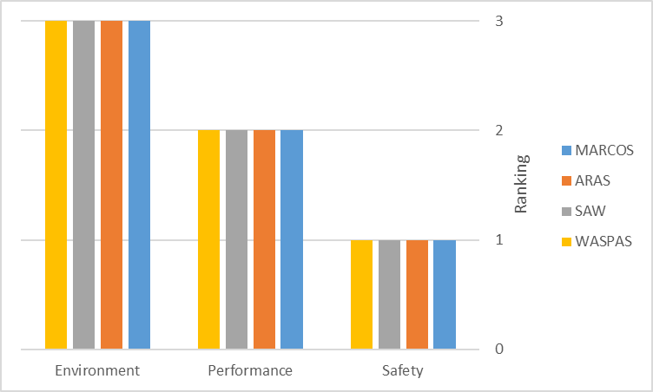

**Figure 3** Comparison of MARCOS method results with other methods

In order to validate the findings, additional analysis was done on the input parameters in addition to the comparison analysis. Simulated weights were calculated for 20 alternative scenarios (Set 1–Set 20) using equation (11), which was based on the most important criterion S1 [22].

 (11)

In this equation,  denotes the altered weights of the criteria, while  denotes the decreased weight of the most significant criterion.  denotes the initial weight of each criterion, while  represents the original weight of the most significant criterion. For the most important criterion S1, the rate of reduction was decreased by 5% in each scenario, and the application was finalized through 20 scenarios. Figure 4 shows the weights calculated for criteria.

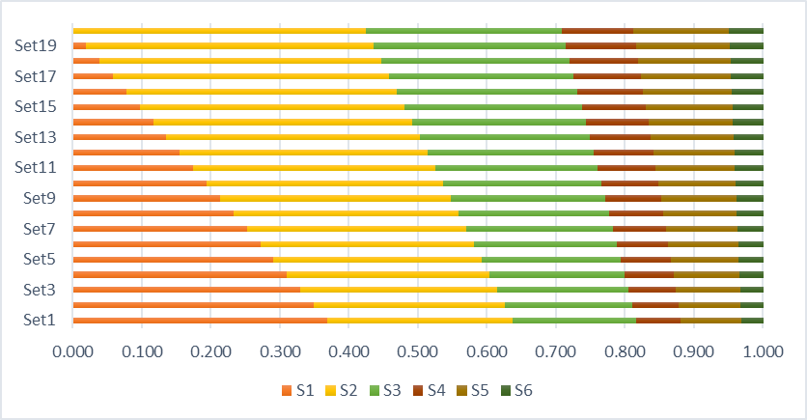

**Figure 4** Criteria weights under 20 scenarios

Figure 5 shows scenario-based rankings using simulated criteria weights. As a result, changes in the weighting of the criterion will affect the ranking. We may, however, draw the conclusion that the scenario-based rankings have not changed significantly. With the exception of the first scenario, A2 ranks first, then A1, and A3 ranks last. Overall, the stability of the computation was produced by comparative analysis and sensitivity analysis based on simulated weights, which both attained a high level of consistency.

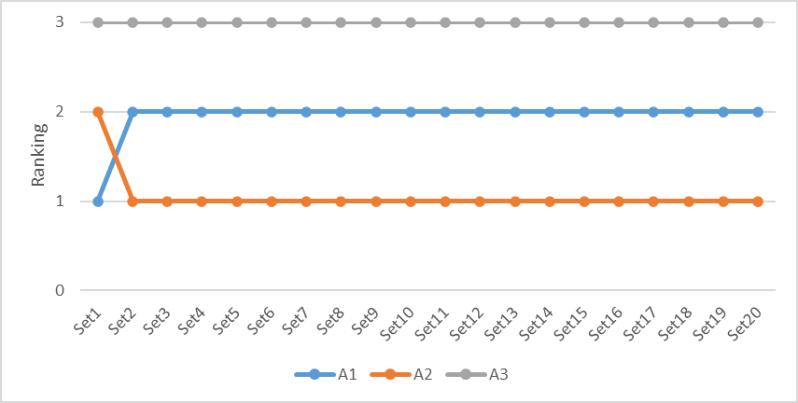

**Figure 5** Scenario-based rankings through 20 scenarios

**4. Conclusion**

We will start by discussing the study's implications. In this study, we concentrated on appropriate intelligent transportation systems that can lessen traffic congestion and the negative environmental impact of urban transportations. The suggested method was thoughtfully created and conducted with two steps. The weights of the study's criteria were determined in the first step, and the systems that may be used to address traffic problems were organized in the second. The road transport sector is the main pillar of various activities in Libya, but it is facing many challenges, including: the increase and development of the need for transport services, the increase in the pollution rate due to the increase in carbon emissions and various pollutants as a result of burning fossil fuels from various means of transport, which has caused the increase in traffic problems and the increase in negative environmental effects. The application of intelligent transport systems can provide radical solutions to traffic problems without the need to create new infrastructure or expand existing ones, through the optimal use of available road networks based on advanced technologies and applications. It is noteworthy here the importance of integrating multiple road transport by involving public transport, encouraging the use of environmentally friendly means of transport and providing the necessary facilities for their use. The model used illustrates the impact of intelligent transport systems on safety, performance and the environment. The research is limited by the systems and assessment factors used in this paper. The socio-economic impact of these systems is one of the areas requiring additional focus.

**Authors' Contributions**

Each author has participated and contributed sufficiently to take public responsibility

for appropriate portions of the content.

**Funding**

No external funding was received for this research.

**Competing Interests**

The authors declare no conflict of interest.

**References**

[1] D. Radović, Ž. Stević, D. Pamučar, *et al.* Measuring performance in transportation companies in developing countries: a novel rough ARAS model. *Symmetry.* 2018;10(10):434 . doi: https://doi.org/10.3390/sym10100434.

[2] O. Elmansouri, A. Almhroog, and I. Badi. Urban transportation in Libya: An overview. *Transportation research interdisciplinary perspectives.* 2020;8:100161. doi: [https://doi.org/10.1016/j.trip.2020.100161](https://doi.org/10.1016/j.trip.2020.100161" \o "Persistent link using digital object identifier" \t "https://www.sciencedirect.com/science/article/pii/_blank).

[3] L. Guevara and F. Auat Cheein. The role of 5G technologies: Challenges in smart cities and intelligent transportation systems. *Sustainability.* 2020;12(16):6469. doi: **<https://doi.org/10.3390/su12166469>.**

[4] K. N. Qureshi and A. H. Abdullah. A survey on intelligent transportation systems. *Middle-East Journal of Scientific Research.* 2013; 15(5):629-642. doi: 10.5829/idosi.mejsr.2013.15.5.11215.

[5] A. Balasubramaniam, A. Paul, W.-H. Hong, et al. Comparative analysis of intelligent transportation systems for sustainable environment in smart cities. *Sustainability.* 2017; 9(7): 1120. doi: **<https://doi.org/10.3390/su9071120>.**

[6] L. Zhao and Y. Jia. Intelligent transportation system for sustainable environment in smart cities. *The International Journal of Electrical Engineering & Education.* 2021;0020720920983503. doi: https://doi.org/10.1177/0020720920983503.

[7] P. Ersoy and G. BÖRÜHAN. Intelligent transportation systems and their applications in road transportation industry in Turkey. *Proceedings of the 12th International Conference on Logistics & Sustainable Transport*. 2015;11-13. Available from  <https://pervinersoy.yasar.edu.tr/wp-content/uploads/2016/01/21.pdf>.

[8] Y. J. Nakanishi and J. C. Falcocchio. Performance assessment of intelligent transportation systems using data envelopment analysis. *Research in Transportation Economics.* 2004;8:181-197. doi: [https://doi.org/10.1016/S0739-8859(04)08009-6](https://doi.org/10.1016/S0739-8859(04)08009-6" \o "Persistent link using digital object identifier" \t "https://www.sciencedirect.com/science/article/abs/pii/_blank)

[9] Z. Juan, J. Wu, and M. Mike. Socio-economic impact assessment of intelligent transport systems. *Tsinghua Science and Technology.* 2006;11(4):339-350. doi: 10.1016/S1007-0214(06)70198-5.

[10] H. Zhang and X. Lu. Vehicle communication network in intelligent transportation system based on Internet of Things. *Computer Communications.* 2020; 160:799-806. doi: https://doi.org/10.1016/j.comcom.2020.03.041.

[11] S. Kaffash, A. T. Nguyen, and J. Zhu. Big data algorithms and applications in intelligent transportation system: A review and bibliometric analysis. *International Journal of Production Economics.* 2021; 231:107868. doi: [https://doi.org/10.1016/j.ijpe.2020.107868](https://doi.org/10.1016/j.ijpe.2020.107868" \o "Persistent link using digital object identifier" \t "https://www.sciencedirect.com/science/article/abs/pii/_blank).

[12] L. Figueiredo, I. Jesus, J. T. Machado, et al. Towards the development of intelligent transportation systems. *ITSC 2001. 2001 IEEE intelligent transportation systems. Proceedings (Cat. No. 01TH8585)*. 2001;1206-1211. doi: 10.1109/ITSC.2001.948835

[13] B. Singh and A. Gupta. Recent trends in intelligent transportation systems: a review. *Journal of Transport Literature.* 2015; 9:30-34. doi: https://doi.org/10.1590/2238-1031.jtl.v9n2a6.

[14] P. Chatterjee and Ž. Stević. A two-phase fuzzy AHP-fuzzy TOPSIS model for supplier evaluation in manufacturing environment. *Operational Research in Engineering Sciences: Theory and Applications.* 2019;2(1):72-90. doi: <https://doi.org/10.31181/oresta1901060c>.

[15] I. Badi and M. Kridish. Landfill site selection using a novel FUCOM-CODAS model: A case study in Libya. *Scientific African.* 2020; 9:e00537. doi: https://doi.org/10.1016/j.sciaf.2020.e00537.

[16] I. Badi and D. Pamucar. Supplier selection for steelmaking company by using combined Grey-MARCOS methods. *Decision Making: Applications in Management and Engineering.* 2020;3(2):37-48. doi: <https://doi.org/10.31181/dmame2003037b>.

[17] L. Muhammad, I. Badi, A. A. Haruna, et al. Selecting the best municipal solid waste management techniques in Nigeria using multi criteria decision making techniques. *Reports in Mechanical Engineering.* 2021;2(1):180-189. doi: <https://doi.org/10.31181/rme2001021801b>.

[18] E. K. Zavadskas, Z. Turskis, Ž. Stević, et al. Modelling procedure for the selection of steel pipes supplier by applying fuzzy AHP method. *Operational Research in Engineering Sciences: Theory and Applications.* 2020; 3(2):39-53. doi: <https://doi.org/10.31181/oresta2003034z>

[19] I. Petrovic and M. Kankaras. A hybridized IT2FS-DEMATEL-AHP-TOPSIS multicriteria decision making approach: Case study of selection and evaluation of criteria for determination of air traffic control radar position. *Decision Making: Applications in Management and Engineering.*  2020;3(1):146-164. doi: <https://doi.org/10.31181/dmame2003134p>.

[20] Ž. Stević, D. Pamučar, A. Puška, et al. Sustainable supplier selection in healthcare industries using a new MCDM method: Measurement of alternatives and ranking according to Compromise solution (MARCOS). *Computers & Industrial Engineering.* 2020;140:106231. doi: [https://doi.org/10.1016/j.cie.2019.106231](https://doi.org/10.1016/j.cie.2019.106231" \o "Persistent link using digital object identifier" \t "https://www.sciencedirect.com/science/article/abs/pii/_blank).

[21] I. Badi, L. Muhammad, M. Abubakar, et al. Measuring Sustainability Performance Indicators Using FUCOM-MARCOS Methods. *Operational Research in Engineering Sciences: Theory and Applications.* 2022;5(2): 99-116. <https://doi.org/10.31181/oresta040722060b>.

[22] I. Badi, M. Jibril, and M. Bakır. A composite approach for site optimization of fire stations. *Journal of Intelligent Management Decision.* 2022;1(1):28-35.